125 High Front Box Gutter
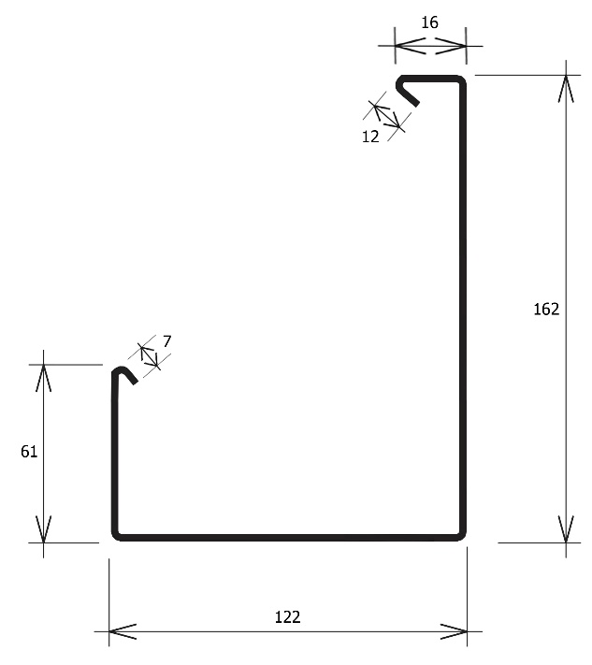

Cross Sectional Area 7380mm²

Components/Add ons | Available | Material/Specifications
Colour Steel | YES | Hand folded 0.55mm gauge
Aluminium | YES | Hand folded 0.90mm – limited colour range
Copper | YES | Hand folded 0.50mm
Internal Brackets | YES | Aviation grade nylon bracket
External Brackets | YES | Aluminium powdercoated. Brass. Copper.
Continuous Longrun | NO | Manufactured in lengths of 8m (max)
Fits 65/80mm Downpipes | YES | PVC or Metal
Fits 100mm Downpipes | YES | PVC or Metal
Fits Leafguard | YES | Custom folded aluminium. Internal brackets only

One of our most recently designed profiles. This product was specifically created to be used with vented roofing/fascia systems. 125 High Front Box gutter has a large capacity and suits both traditional and contemporary homes. With a front face that sits over 100mm higher than the back this spouting product has an unparalleled ability to cover the roof ends. It is ideal for use on vented fascia, low pitched roofs and older homes where there are gaps between the fascia and roof. High front is a great alternative on domestic homes where the larger more commercial size box gutters would look out of place.

